**Excel Assignment 4**

1. What is the benefit of Microsoft 365?

One of the main advantages of Office 365 is that it **allows users to work from anywhere as long as they have internet connectivity**. Because Office 365 is entirely cloud-based, emails, files, and popular Office programs (such as Word, PowerPoint, and Excel) can be accessed from any location and any device.

1. Use two datasets and perform join on specific columns.

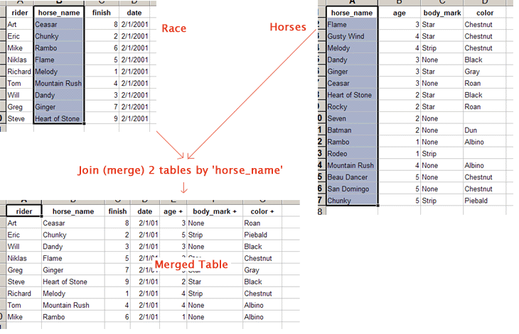

1. How to perform string formatting in excel. Demonstrate it with examples.

To see that dialog box and get the syntax, follow these steps:-

* Right-click any cell and select Format Cell.
* On the Number format tab, select the formatting you need.
* Select Custom from the Category list on the left of the Number Format dialog box.
* Copy the syntax found in the Type input box.

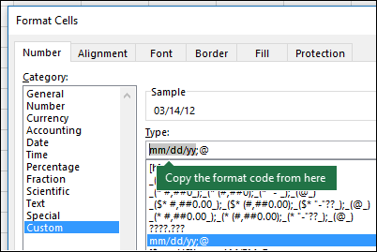

1. Create an advance expense distributor in excel.

Example: Consider expenses of a person who will be entered in excel at the same time expenses must be evenly distributed among all people with the amount of money each person should return/ receive.

1. Create reports to generate mark sheets of students in excel where percentages and addition of marks should be done using formulas.